CHAPTER THREE
ANALYSIS

3.0 Introduction

In this chapter, we will discuss and analyze the development process of the Online Bookstore Management System including software requirement specification (SRS) and a comparison between the existing and proposed system. The functional and non-functional requirements are included in the SRS part to provide a complete description and overview of system requirements before the developing process is carried out. Besides that, existing vs proposed provides a view of how the proposed system will be more efficient than the existing one.

3.1 Existing System Description
The job seekers enter the website home page and see the latest jobs in the top
Then the click in the link to find out more about the job, then he reads the job
Description and other details then he clicks on apply button to apply to the job
Then he need to login or signup if he has no account to apply to the job and then
The employers see his documents and CV then they interview him.
3.2 System Requirement
A Functional Requirement (FR) is a description of the service that the software must offer. It describes a software system or its component. A function is nothing but inputs to the software system, its behavior, and outputs. It can be a calculation, data manipulation, business process, user interaction, or any other specific functionality which defines what function a system is likely to perform. Functional Requirements are also called Functional.

3.2.1 Functional Requirements
- The system should store information about new entry person
- The system must show available works in the current time of searching
- The system must show the location of the job
- The system should maintain a quantity record
- The system must have the ability to delete and update the record.
- The system also must have security to prevent data

3.2.2 Non-functional Requirements
- Maintenance: The store Management System is being developed in PHP. PHP is an object-oriented programming language and shall be easy to maintain
- Portability: -Shaqadoon Job Portal System shall run in WINDOWS 7/8 or above environment that contains PHP Runtime.
- Reliability: The system must be reliable and meet user needs requirements. Increasing the performance of the software will improve the reliability of the software and storing backup data can increase reliability of the software.
- Standards Compliance: The system must be user-friendly and easy to use.
- Performance: The system must be in good performance and
- Security: One of the most important non-functional requirements is security. Security requirements can come in many different forms:
- Privacy: Requirements can dictate protection for sensitive information. Some types of privacy requirements include: data encryption for database tables, policies regarding the transmission of data to 3rd parties (e.g., scrambling user account numbers), etc... Sources for privacy requirements could be legislative or corporate.
- Physical: These requirements relate to the physical protection of the system. Other types of physical requirements include items such as elevated floors (for server cooling), fire prevention systems, etc…
- Access: Access requirements define account types / groups and their access rights. An example of an access requirement could be to limit each account to one login at a time or to restrict where an application can be deployed or used.

3.2.3 Hardware Requirements

Hardware | Minimum System requirement
Processor | 2.4 GHZ processor speed
Memory | 4 RAM
Disk space | 5 Gb (Including 1.5 Gb Database Management System)
Display | 800 x 600 colors (1924 x 1080 higher)

3.2.4 Software Requirements
Software Requirement | Minimum System requirement
Operating System | Windows 7/8 or Above Operation System
Database | MYSQL
Programming languages | PHP, HTML, CSS, JAVASCRIPT
Compiler | Visual Studio SDK
Web browser | Firefox, Chrome etc.

3.3 Requirement (Functional) Modeling of the Proposed System
- The user needs a SQL Server for Database storage.
- The user needs a System Step up.
- The user needs to have a Bookstore Management System account.
- The user needs to have System Admin privileges.
.

System admin
- System Admin logs in to Online Bookstore Management System
- A system admin then clicks the home button
- His settings to create a new user.
- The administrator clicks the reports button to print every report he wants.

3.3.1 Data Flow Diagram (DFD)

DFDs show the flow of data from external entities into the system and showed how the data
moved from one process to another, as well as its logical storage. There are only four symbols:
- Squares represent external entities, which are sources or destinations of data.
- Rounded rectangles represent processes, which take data as input, do something to it,
and output it.
- Arrows represent the data flows, which can either, be electronic data or physical items.
- Open-ended rectangles represent data stores, including electronic stores such as
databases or XML files and physical stores such as filing cabinets or stacks of paper.

There are several common modeling rules for creating DFDs:
- All processes must have at least one data flow in and one data flow out.
- All processes should modify the incoming data, producing new forms of outgoing data.
- Each data store must be involved with at least one data flow.
- Each external entity must be involved with at least one data flow.
- A data flow must be attached to at least one process.
DFDs are nothing more than a network of related system functions and indicate from where
information is received and to where it is sent. It is the starting point in the system that
decomposes the requirement specifications down to the lowest level of detail.

The four symbols in DFD, each of which has its meaning. They are given below:
- External entities are outside to system but they either supply input data in the system or
use the system output. These are represented by a square or rectangle. External entities
that supply data into a system are sometimes called Sources. External entities that use
system data are sometimes called sinks.
- Dataflow models that passages of data in the system are represented by lines by joining
system components. An arrow indicates the direction of the flow and the line is labeled
by the name of the data flow.
- The process shows that the systems do. Each process has one or more data inputs and
one or more data outputs. Circles in DFD represent them. Each high-level process may
be consisting of more than one lower-level process. The process will be expanded in
sequent level DFD. A circle or a bubble represents a process that transforms incoming
data flow into outgoing data flow.
The high-level processes in a system are:
- Receivable process.
- Verifiable process.
- Disposal process.
- A file or data store is a repository of data. They contain data that is retained in the
system. The process can enter data into the data store or retrieve data from the data
store. An open rectangle is a data store, data at rest

3.3.1.1 Context Diagram (Sample)

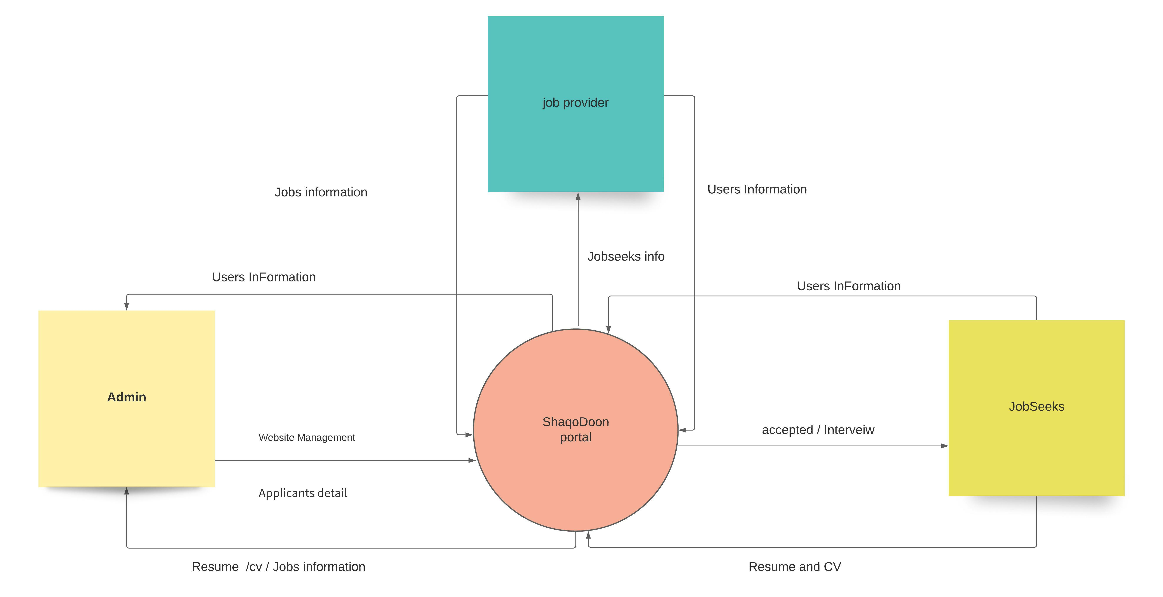

3.3.1.2 Level-0 Diagram

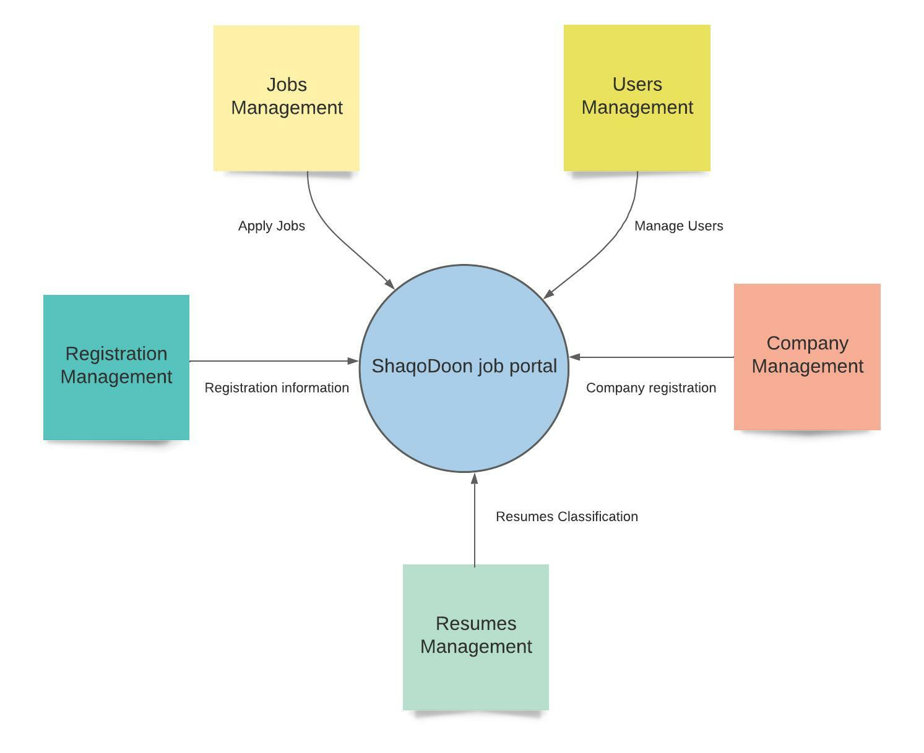

3.3.1.3 Level-1 Diagram

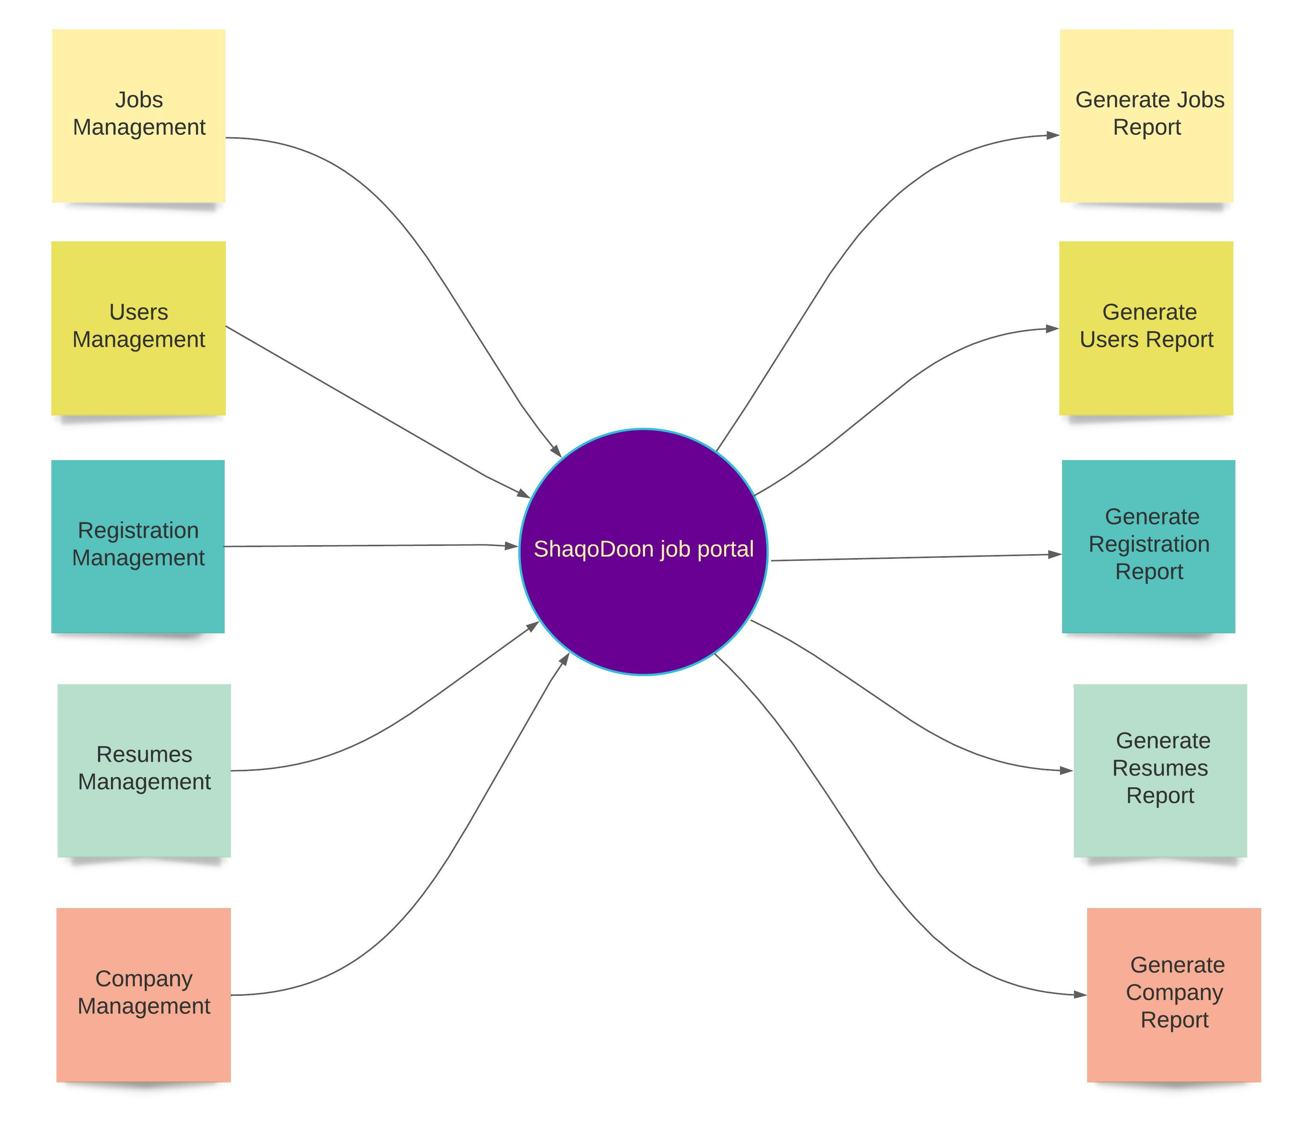

3.4 Use Case Diagrams

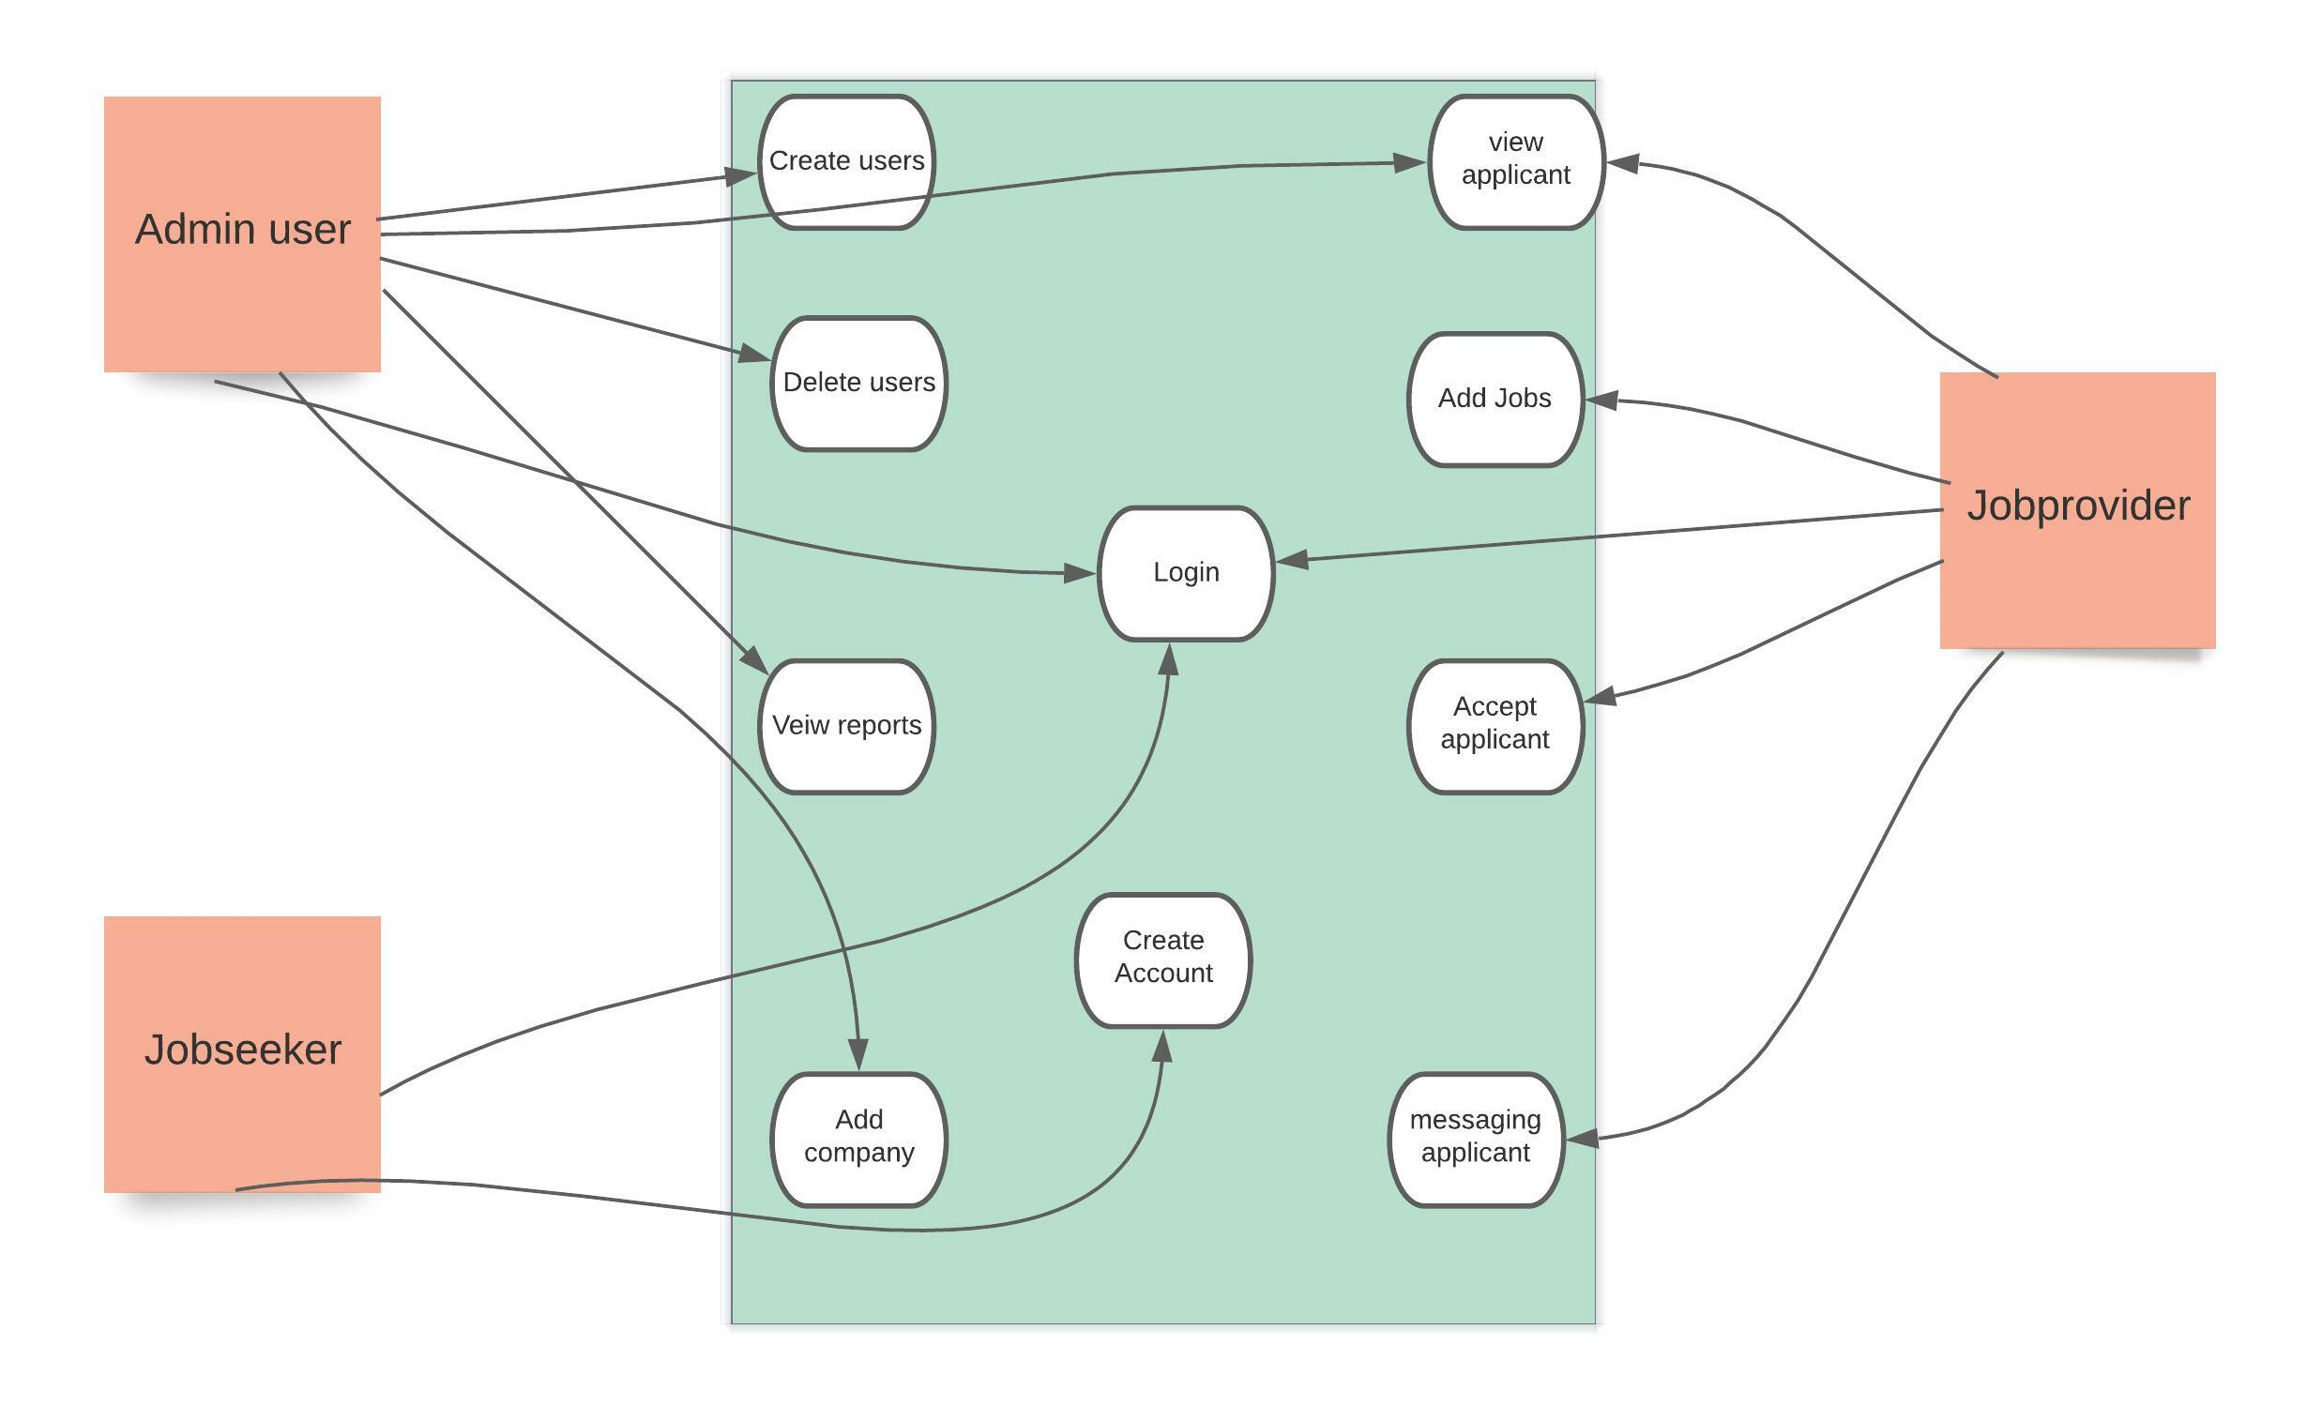

3.4.1 Use Case Descriptions

We have three main actors in our system:
- Administrator: Mainly responsible for creating, deleting users and Add Companies.
- Job provider: Mainly responsible for Adding jobs, Viewing Applicant, Accepting Applicant.
- Jobseeker: Mainly responsible for Applying for the jobs and Creating its own account.

Here are the top use cases of the Shaqo Doon partial System:
- Login: The use case is start when the actors will be Login to the admin/user panel. It will be finish when the actors will be logout.
- Register: The Use case is start when the actors sign up.
- Approve Jobs: The use case is start when the actor will be Login and access Approve jobs.

3.4.2 Activity Diagrams
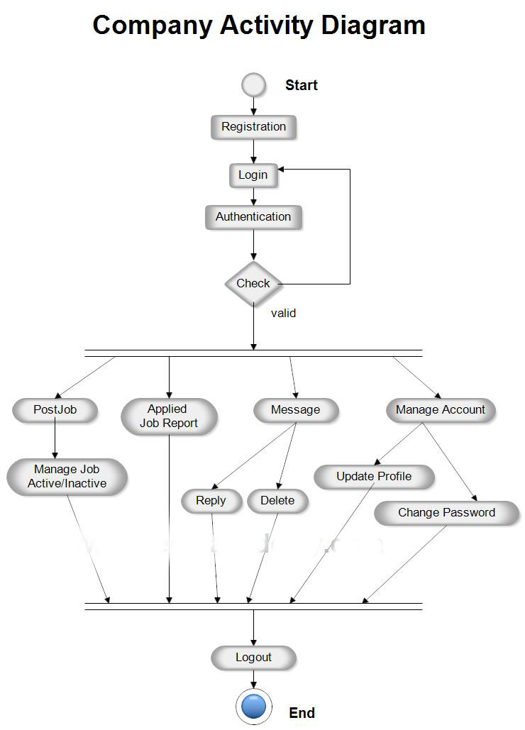

3.4.3 Sequence Diagrams
The sequence diagram represents the flow of messages in the system and is also termed an
event diagram. It helps in envisioning several dynamic scenarios. It portrays the communication
between any two lifelines as a time-ordered sequence of events, such that these lifelines took
part in the run time. In UML, the lifeline is represented by a vertical bar, whereas the message
flow is represented by a vertical dotted line that extends across the bottom of the page. It
incorporates the iterations as well as branching.
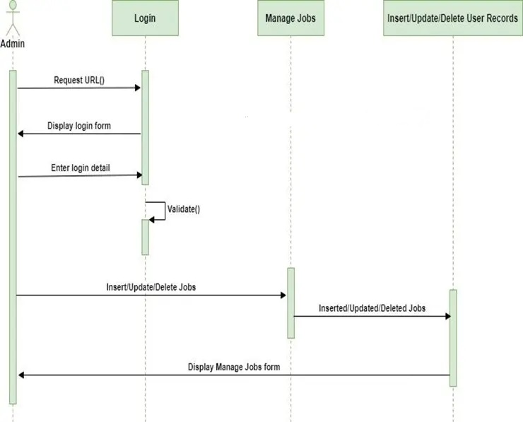

3.5 Object Modeling of the Proposed System (Class Diagram)
The class diagram is static. It represents the static view of an application. The class diagram is
not only used for visualizing, describing, and documenting different aspects of a system but also
for constructing executable code of the software application.
The class diagram describes the attributes and operations of a class and also the constraints
imposed on the system. Since they're the only UML diagrams that can be translated directly to
object-oriented languages, class diagrams are frequently utilized in the designing of objectoriented systems. The class diagram shows a collection of classes, interfaces, associations,
collaborations, and constraints

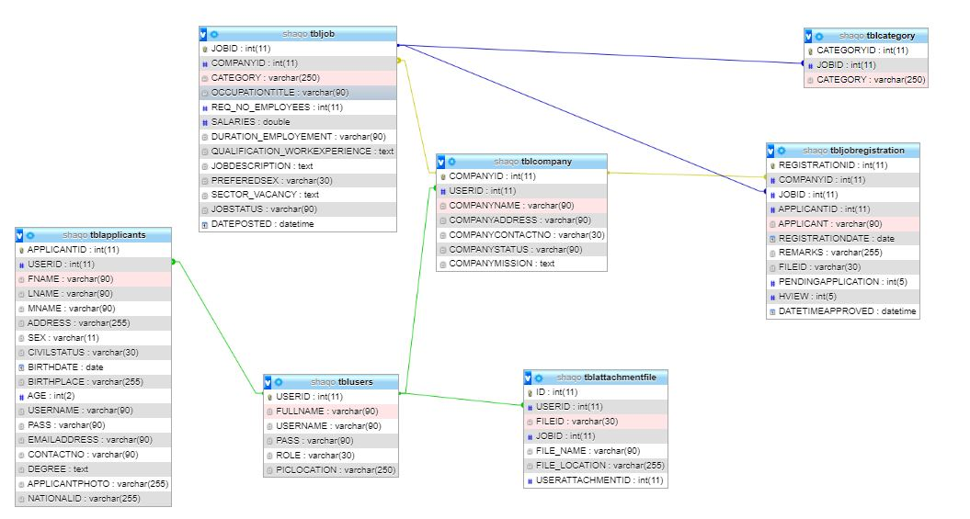

3.6 Data Modeling of the Proposed System (Conceptual Data Modeling using ERD)
Modeling is an efficient and effective way to represent the organization’s needs; it graphically
provides information to the members of an organization to understand and communicate the
business rules and processes.
